EXPT NO:4 | TRANSFORM DATA TO SUIT BI REPORTING REQUIREMENTS AND  DESIGN A DASHBOARD WITH KEY PERFORMANCE INDICATORS (KPIs ) USING TABLEAU AND POWERBI
DATE: 24.07.2026

PRE-LAB QUESTIONS (PROVIDE BRIEF ANSWERS TO THE FOLLOWING QUESTIONS)
- What is the role of data transformation in BI reporting?
Data transformation converts raw data into a clean and structured format. It improves data quality, consistency, and accuracy, making it suitable for analysis and reporting.

- What are the common data cleaning techniques in Tableau and Power BI?
- Removing duplicate records
- Handling missing or null values
- Correcting data types
- Filtering incorrect data
- Renaming columns and formatting values

- How do Tableau and Power BI handle data aggregation?
Tableau and Power BI automatically aggregate numerical data using functions like SUM, AVERAGE, COUNT, MIN, and MAX. Data can also be grouped by categories such as country, continent, or date.

- What are KPIs, and why are they important in a dashboard?
KPIs (Key Performance Indicators) are measurable values used to evaluate performance. They provide quick insights into important metrics such as total cases, deaths, and vaccination rates for better decision-making.

- What are the different types of charts available in Tableau and Power BI for visualization?
- Bar Chart
- Line Chart
- Pie Chart
- Area Chart
- Scatter Plot
- Map
- Tree Map
- Donut Chart
- KPI Card
- Table and Matrix

IN-LAB EXERCISE:
OBJECTIVE:
To transform COVID-19 data into a structured format suitable for Business Intelligence (BI) reporting and design interactive dashboards with Key Performance Indicators (KPIs) using Tableau and Power BI.
PROCEDURE:
- Data Collection:
  - Import the COVID-19 dataset from inbuilt sources like Our World in Data or CSV files containing country-level COVID statistics (e.g., new cases, deaths, vaccinations).
  - Datasets may include fields such as date, location, new_cases, total_cases, new_deaths, total_deaths, people_vaccinated, etc.
- Data Cleaning and Transformation:
  - Convert columns like date to proper date formats.
  - Handle missing or null values in new_cases, total_cases, etc.
  - Create calculated fields (e.g., daily case growth rate, case fatality rate, vaccination percentage).
- Data Aggregation:
  - Aggregate data by continent, country, or month.
  - Use measures like SUM(new_cases), AVG(positivity_rate), MAX(total_deaths).
- Designing KPIs:
  - Identify KPIs such as:
    - Total Confirmed Cases o Total Deaths o Case Fatality Rate o Vaccination Coverage (%)
    - Daily Case Growth Rate
  - Use DAX (Power BI) or Calculated Fields (Tableau) to compute and visualize these KPIs.
- Dashboard Development:
  - Build visualizations such as:
    - Line charts for daily new cases and deaths o Bar charts for country-wise vaccination progress o Maps to show regional case distribution
    - KPI cards for high-level insights
  - Use filters (e.g., by continent, country) and slicers (e.g., by date range) for interactivity.
- Publishing and Sharing:
  - Publish the dashboard using Tableau Public/Server or Power BI Service.
  - Share the dashboards with stakeholders through public or organizational portals.
Experiment Dataset: COVID-19 Global Dataset
Fields Used:
  - Date – Date of the report
  - Location – Country or region
  - New Cases – Daily reported cases
  - New Deaths – Daily reported deaths
  - People Vaccinated – Cumulative vaccinated count
  - Total Cases – Cumulative confirmed cases
  - Total Deaths – Cumulative deaths
  - Population – Total population of the country

Screenshot: (Power BI)

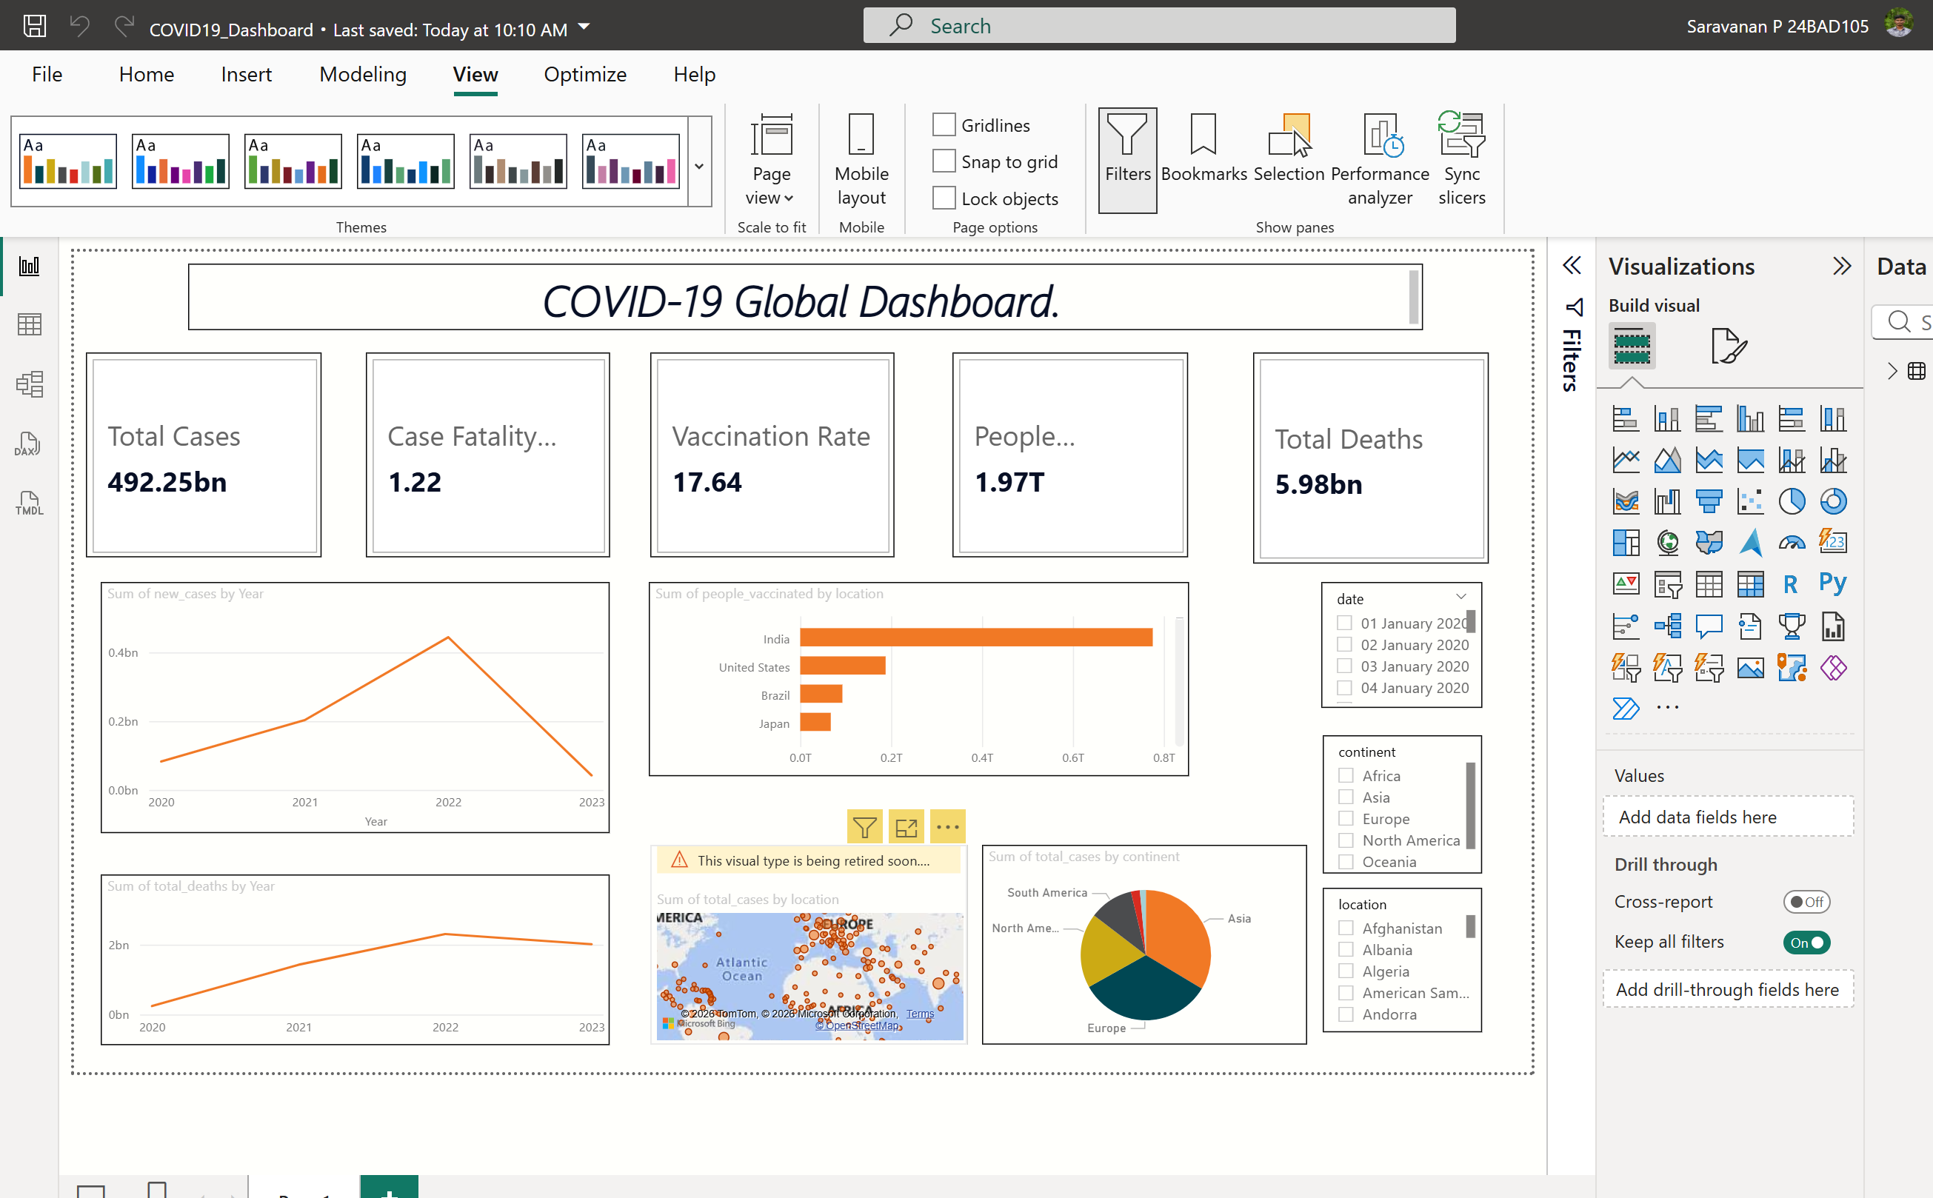
Screenshot: (Tableau)
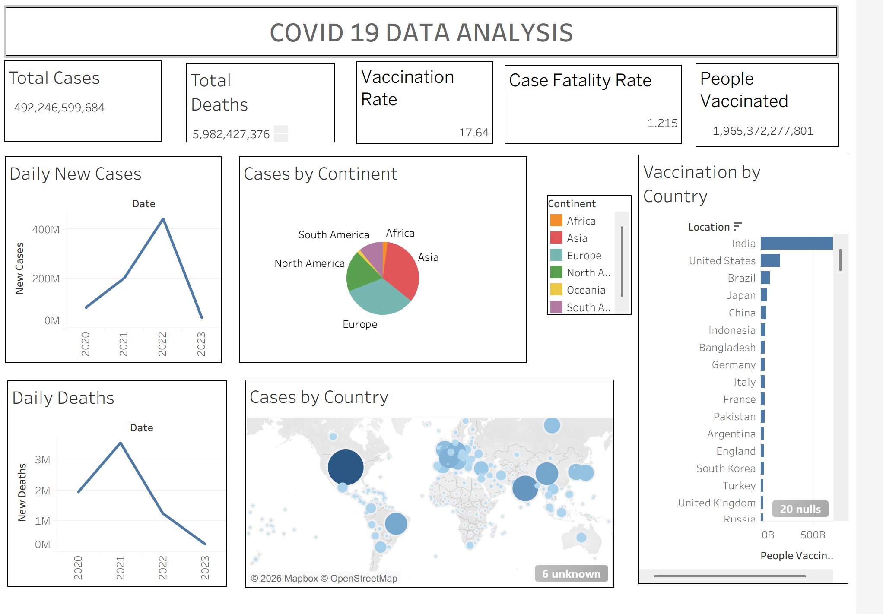

POST-LAB QUESTIONS (PROVIDE BRIEF ANSWERS TO THE FOLLOWING QUESTIONS)
  - How did data transformation improve the quality of insights in your COVID-19 dashboard?

Data transformation cleaned and organized the dataset by fixing missing values and formatting issues. This improved the accuracy and reliability of the dashboard insights.

  - What challenges did you encounter during the data cleaning process, and how did you resolve them?

The main challenges were missing values, inconsistent date formats, and incorrect data types. These were resolved by replacing null values, converting dates into the correct format, and correcting data types using Power Query/Tableau.

  - Which KPI provided the most valuable insight, and why?

The Vaccination Coverage (%) KPI provided the most valuable insight because it showed the progress of vaccination across different countries and helped compare public health responses.

  - How does interactivity in dashboards improve user experience?

Interactive dashboards allow users to filter, sort, and explore data easily. This helps users focus on specific countries, regions, or time periods and gain better insights.

  - What steps would you take to further enhance the dashboard’s effectiveness?

- Add more KPIs and trend analysis.
- Include predictive forecasting.
- Improve dashboard layout and color themes.
- Add drill-down and drill-through features.
- Enable real-time data updates.

RESULT:

The COVID-19 dataset was successfully cleaned, aggregated, and transformed for visual analysis using Tableau and Power BI. Missing values, data type mismatches, and inconsistencies were addressed. KPIs such as vaccination rate and daily case growth offered valuable insights into the pandemic trends across countries and timeframes. The resulting interactive dashboards allowed for effective public health monitoring and communication.

ASSESSMENT

Description |  | Max Marks | Marks Awarded
Pre Lab Exercise |  | 5
In Lab Exercise |  | 10
Post Lab Exercise |  | 5
Viva |  | 10
 | Total | 30
 | Faculty Signature

